Exercise 1: Implementing the Singleton Pattern
Singleton.java
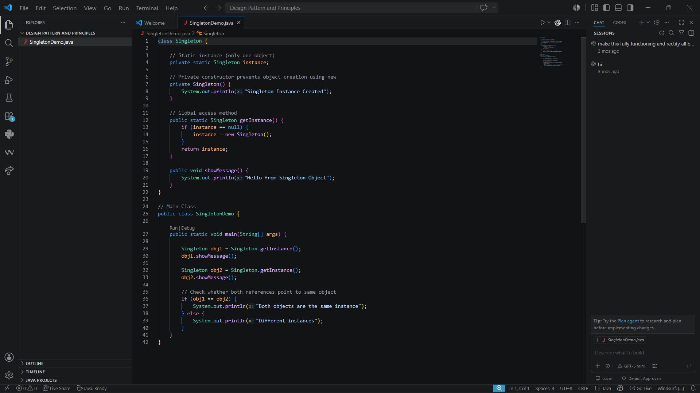
Output:
